WiFi Robot: Control Robot Over WiFi

*Evan Yang（015564055）*

# Introduction

IoT stands for the "Internet of Things," which refers to the interconnectedness of physical objects that can exchange data over the internet. This project aims to control a remote control car using WiFi. The user should be able to wirelessly control the car's movements, and the car will be powered by a battery. The user sends a request to the local server spun up by the MKR WiFi 1010. After processing the request, the MKR WiFi sends instructions to the Motor Shield Rev3 through the MKR2UNO adapter, and the Motor Shield Rev3 drives the motors based on the instructions.

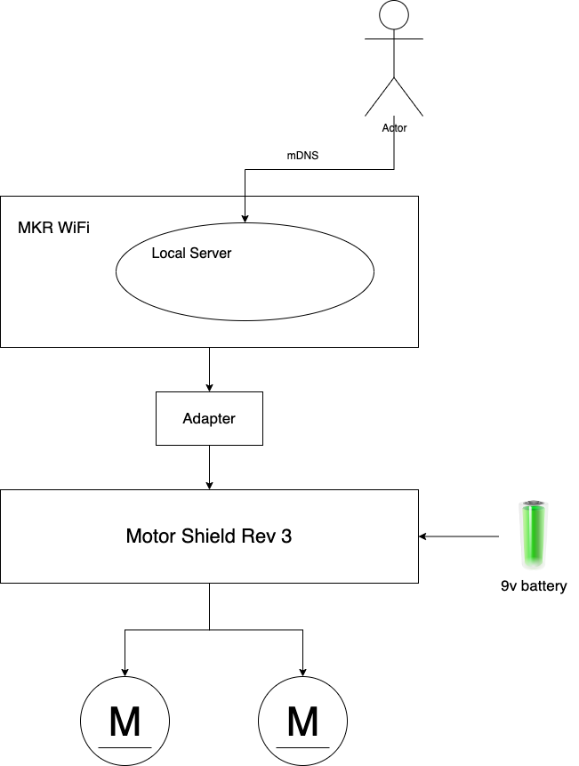

*Figure 1. High-Level Architecture*

# Material

There are three Arduino boards involved in this project. In comparison to Raspberry Pi, Arduino is smaller in size and more energy-efficient. The three Arduino boards used in this project are:

1. MKR WiFi 1010[1], which connects to Wi-Fi and sets up a local server to process requests from the user.
2. Motor Shield Rev3[2], which contains an L298 chip - a dual full-bridge driver designed to drive inductive loads such as relays, solenoids, DC, and stepping motors. It enables the control of two DC motors independently, controlling their speed and direction.
3. MKR2UNO Adapter[3], which is needed to connect the boards mentioned above since they have different pins. Alternatively, I could use ARDUINO UNO WiFi REV2. However, I believe this board has more functionality than I need and consumes more power. The operating voltage of the MKR WiFi 1010 is 3.3v, while that of the ARDUINO UNO WiFi REV2 is 5v.

In addition to the boards, I am using two 3v DC motors to drive the car. For the car's casing, I recommend using 3mm plywood since the 6mm Birch plywood I purchased from Home Depot is too heavy for the motor to move. Other gadgets such as wire, battery snap, and a 6 AA cell battery holder are also needed. I also purchased a digital multimeter to measure the battery's voltage since the 9v battery I bought was already decayed and its voltage was insufficient to drive the car.

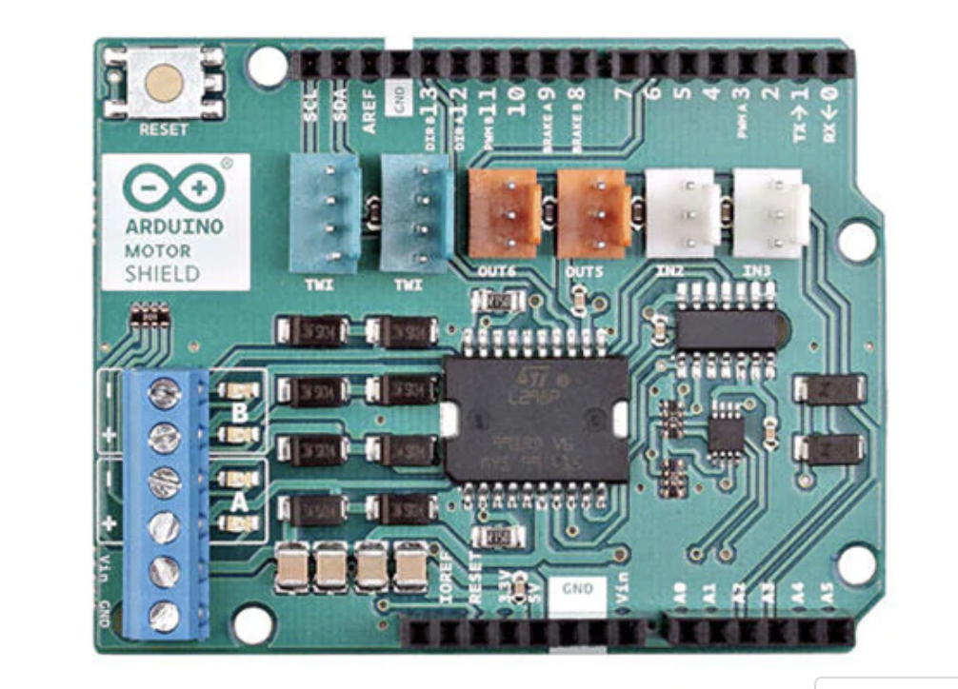

*Figure 2. Motor Shield Rev3*

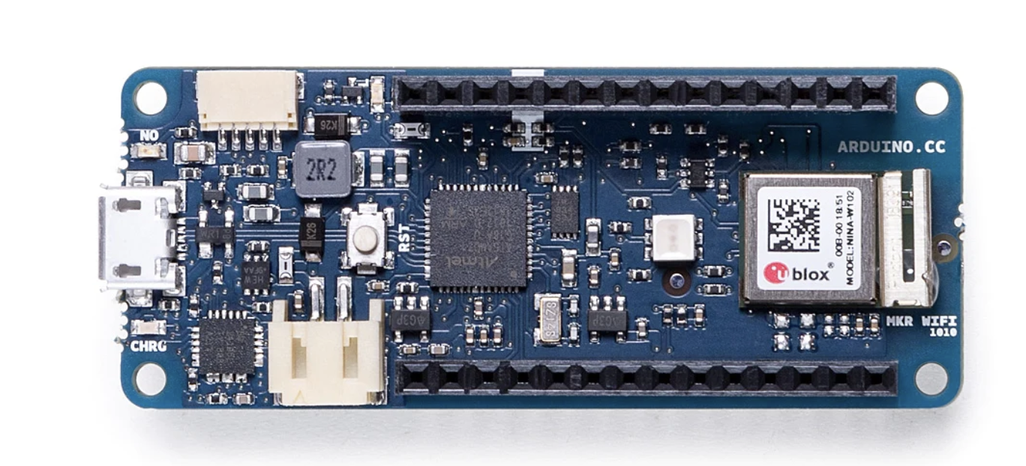

*Figure 3. MKR WiFi 1010*

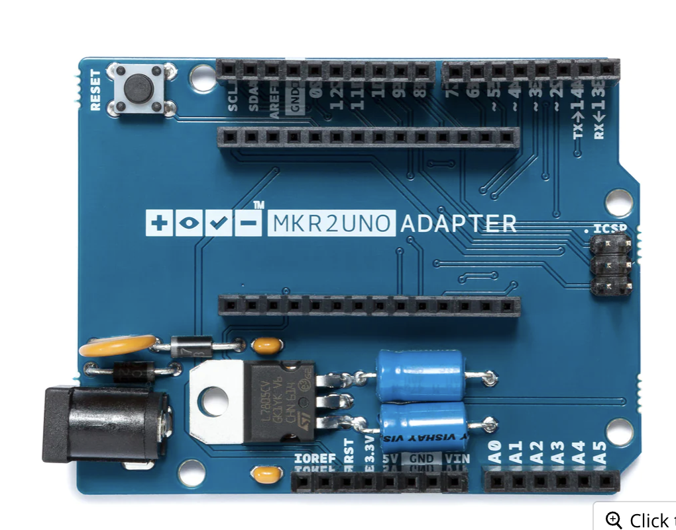

*Figure 4. MKR2UNO Adapter*

# Methodology

1. Assemble the three boards together.
2. Modify the "secret.h" file in the code to enable the MKR WiFi 1010 to connect to the Wi-Fi network. Then, upload the code to the MKR WiFi 1010 using Arduino IDE.
3. Assemble the car's case. I used a laser cutter to cut out the plywood.
4. Connect the motors and the external power.

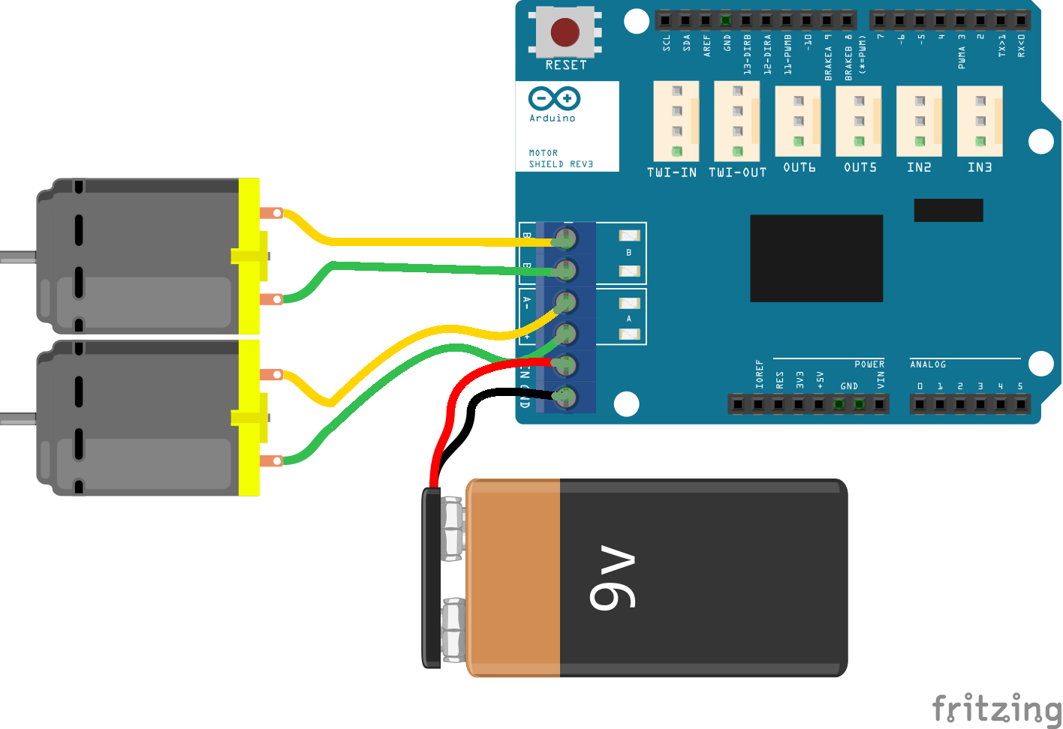

*Figure 5. Circuit diagram[4]*

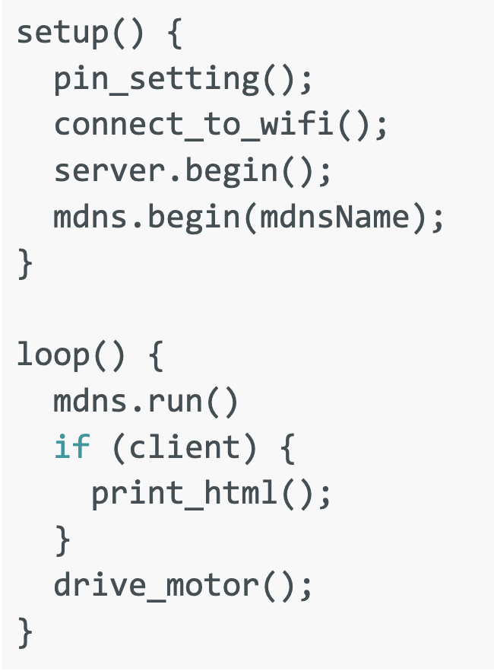

*Figure 6. Pseudo code*

# Results

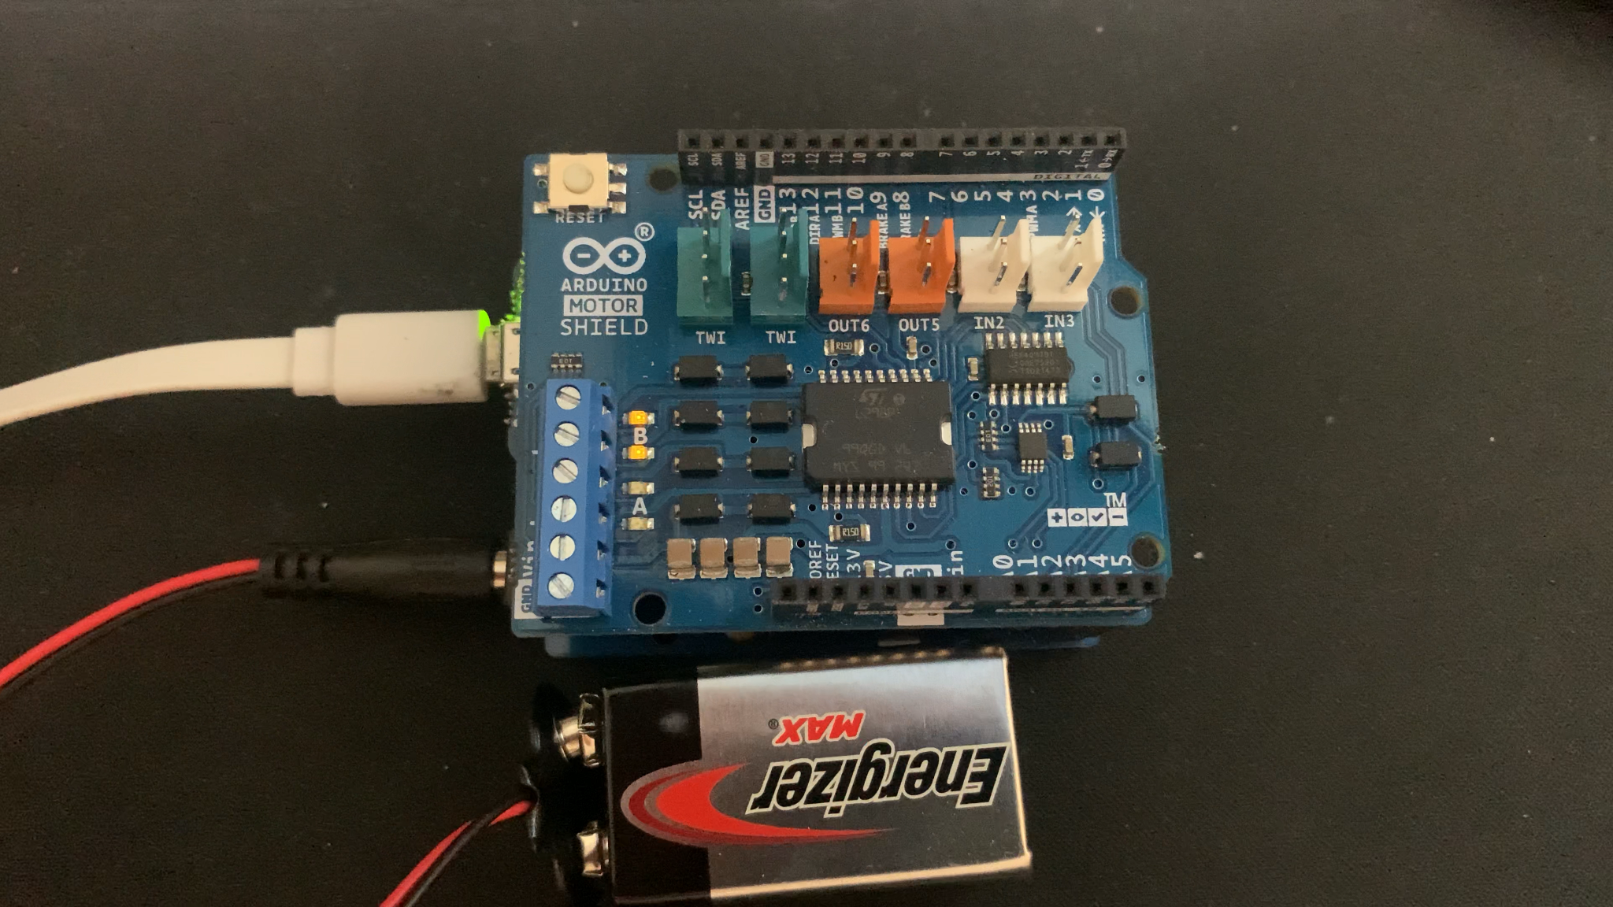

*Figure 7. LED turns on and off when clicking the button from web page*

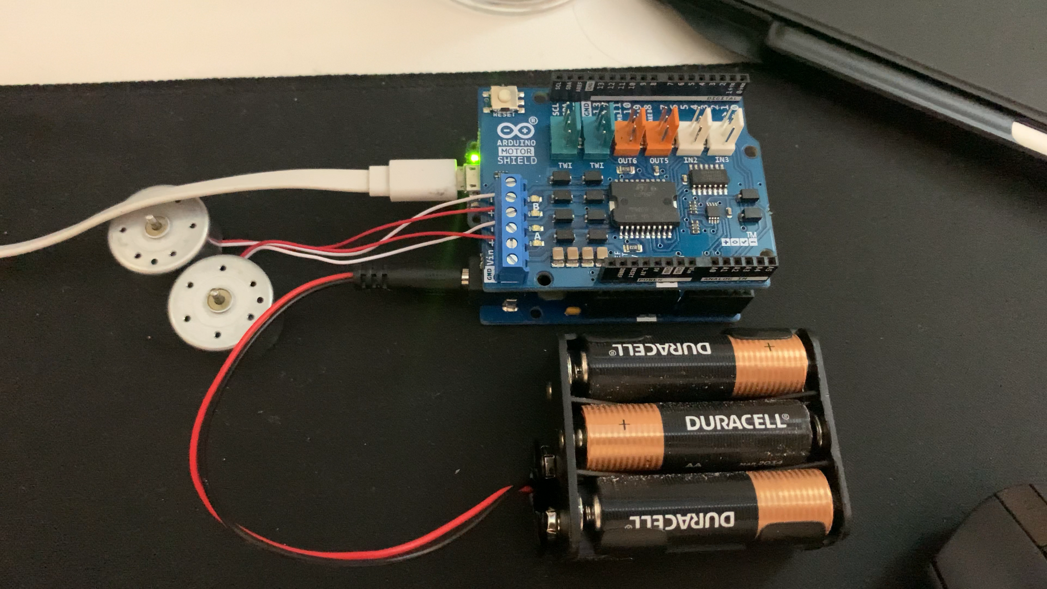

*Figure 8. Connected with motors and battery*

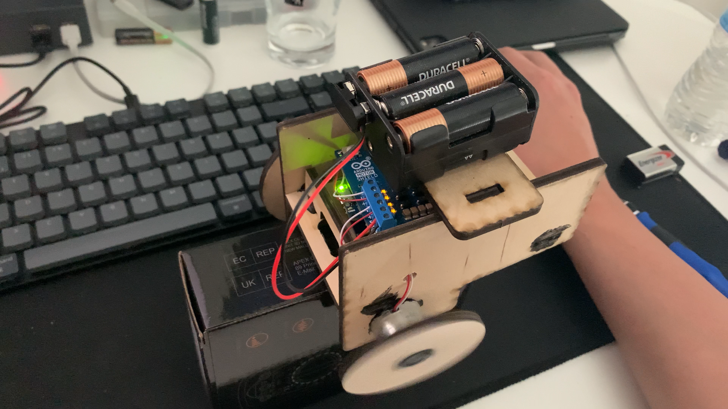

*Figure 9. The final result*

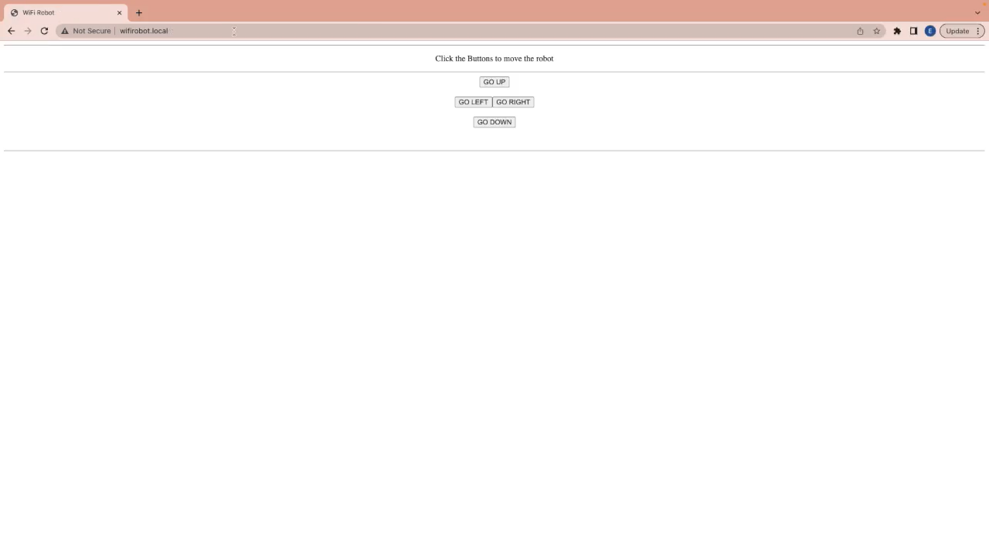

*Figure 10. The control panel*

# Discussion

I referenced the code from Arduino Project Hub[4], but since the project is relatively old, I needed to update the library. The Arduino board used in this project, the MKR 1000 WiFi, has reached the end of its life, so I used a newer board, the MKR WiFi 1010, instead. The library is different between these two boards. The MKR 1000 WiFi uses "wifi101.h", while the MKR WiFi 1010 uses "wifiNINA.h". The syntax is also different, so I had to make some modifications to the code.

When the car is not connected to the laptop, we cannot get its IP address via the serial monitor. Therefore, we need a service like DNS. Multicast Domain Name System (mDNS)[5] is a protocol that resolves hostnames to IP addresses within small networks that do not include a local name server. When any device wants to resolve the hostname, it multicasts the message to every device on the network. The target device then multicasts the message with its local IP address back to all the devices on the network. The other devices can then save the information in their cache for later usage. The hostname needs to end with ".local". Whenever you type in a hostname that ends with ".local", it is actually processed as an mDNS protocol first. I used "wifirobot.local" as the hostname. The library also needs to be updated. I used "ArduinoMDNS.h" here. Since the mDNS sends UDP packets via IPv4 address 224.0.0.251 and port 5353, it needs an additional library, "WiFiUdp.h".

In addition to updating the library, I fixed some bugs in the code. There were some mistakes in the wheel controlling code, and another bug was related to string comparison. When sending a request like "go_up", the board actually receives a long string that can include "GET GO_UP" and reference "GO_DOWN", which is the previous instruction, because the URL has been substituted to "<http://wifirobot.local/?GO_DOWN>". So in the string comparing function, I need to ignore the key words from the reference.

I also noticed that whenever I send a request to the board, there will be two requests. The other one requests "favicon.ico", which is the icon for the page. This is the default behavior of browsers. I just ignore this request and return code 204.

Finally, the Motor Shield Rev3 needs at least 9 volts of external power to drive the two motors. If the voltage is below 9v, the board will start to glitch and the motor will keep driving ceaselessly.

# Reference

[1] Arduino MKR WIFI 1010. Arduino Online Shop. (n.d.). Retrieved April 25, 2023, from https://store-usa.arduino.cc/products/arduino-mkr-wifi-1010

[2] Arduino Motor Shield REV3. Arduino Online Shop. (n.d.). Retrieved April 25, 2023, from https://store-usa.arduino.cc/products/arduino-motor-shield-rev3?selectedStore=us

[3] MKR2UNO adapter. Arduino Online Shop. (n.d.). Retrieved April 25, 2023, from https://store-usa.arduino.cc/products/mkr2uno-adapter?selectedStore=us

[4] MKR1000 WIFI Robot. projecthub.arduino.cc. (n.d.). Retrieved April 25, 2023, from https://projecthub.arduino.cc/Arduino_Genuino/66ad1a27-b5da-487e-a4e1-06e07c0efb32?ref=userrespected&amp;ref_id=484&amp;offset=278

[5] Wikimedia Foundation. (2023, April 4). Multicast DNS. Wikipedia. Retrieved April 25, 2023, from https://en.wikipedia.org/wiki/Multicast_DNS